Rules for Hippocampus Contour Tracing in Oblique Coronal Slices

How to Use MultiTracer (basic operations):

- Click on “File” “Open First Volume” and select file.
- Click on “Orient” and then “Display XYZ= File XZY” and then click on “Display Vertical”. Note: these functions may need to be adapted based on the orientation of the data.
- Set Intensity and Blackness (applies to MultiTracer users).
- *Brain slices should have the highest contrast possible between hippocampus and the surrounding white matter (open at slice 108, blackness ~100 and scale ~170). Note: scaling values will depend on the intensity range of the data and the computer being used. For inter-rater validity, adjust image intensity accordingly.
- Magnify to desired level by typing in choice in the “Magnify By” box.
- Change the name of the contour by typing in desired name in the box, which initially has a temporary name – Press Enter.
- To change structure color click on “Contours” “Set Structure Color” and select desired tracing and editing color.
- To add another structure click on “Contours” “Add Structure”.

Refer to the following link for detailed MultiTracer instructions:

http://air.bmap.ucla.edu/MultiTracer/MultiTracer.html

General Starting and Drawing Rules:

Starting Guidelines and Hippocampal Head

1. Begin drawing at approximately slice 136 (coronal view). In the coronal plane, white matter from the parahippocampal gyrus serves the inferior boundary and white matter from the alveus serves as the superior boundary. The gray matter of the pes hippocampus is situated between these two boundaries. If the superior boundary (white matter of the alveus) cannot be determined, the arch of white matter separating the hippocampus from the amygdala in the sagittal plane can used to estimate the boundary. Note: to accurately determine the starting point for hippocampal tracing, one should enlarge the sagittal view to at least 2x magnification, and make sure that the starting point is posterior to the white matter border of the alveus. Begin tracing on the most anterior coronal slice that is posterior to the alveus [See Fig. 1a for sagittal view]. In the coronal plane the most anterior hippocampal slice should outline into a triangular gray area (pes hippocampi), which enlarges as one moves posteriorly. Gray = Hippocampus [Fig. 1b].

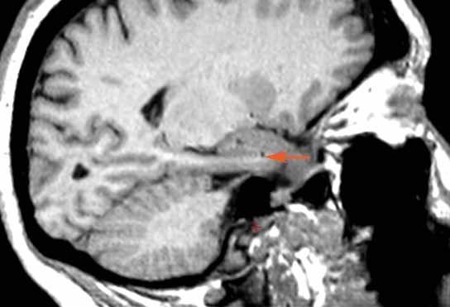

Fig. 1a

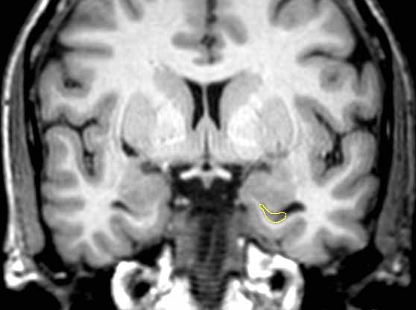

Fig. 1b
2. Start at the most medial superior point and draw counter-clockwise for the right hemisphere, and clockwise for the left hemisphere (medial takes priority over superior). When the uncinate gyrus appears above the hippocampal fissure, always begin drawing at the most medial point, inferior to the hippocampal fissure [See Fig. 2a].

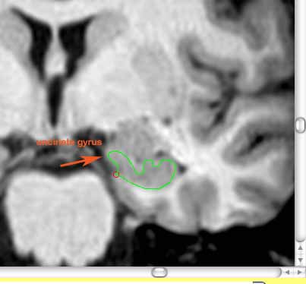
Fig. 2a

3. Always draw to the ventricle, unless there is clearly defined white matter separating the hippocampus and the inferior horn of the lateral ventricle. When drawing up to the ventricle, always include dark gray material (but not choroid plexus in the ventricle), but not black. Also note that sometimes the ventricle will be closed and look like gray matter – this should not be included as hippocampal gray matter [See Fig. 3a for exception].

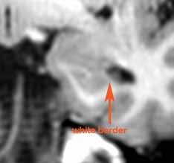

Fig. 3a
4. Maintain the “roundness” of the hippocampus inclusive of blurry white matter, until a clearly defined white border is encountered.

5. If ever uncertain about possible exclusivity of a region, refer to the anterior and posterior brain slice, to determine the shape of developing hippocampus [See Fig. 4a and 4b].

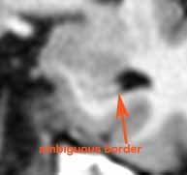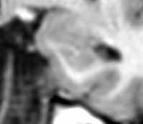

Fig. 4a: Anterior slice Fig. 4b: Posterior slice shows clearly defined border

6. If there is no clearly defined superior border of the hippocampus, follow the ventricle until the most medial point, and then draw a straight line to the uncinate gyrus. Finally, follow the gray matter down to the starting point [See Fig. 5a and 5b].

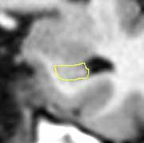
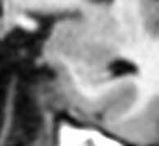

Fig. 5a: Without contour line Fig. 5b: With contour line

7. When digitations (wave-like wide round ridges) in the superior border of the hippocampus appear, always follow the contours closely and precisely (digitations will occur in anterior hippocampal regions only) [See Fig. 6a and 6b].
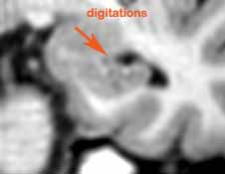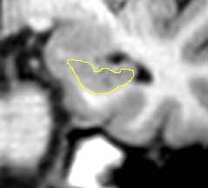

Fig. 6a: Without contour line Fig. 6b: With Contour Line

8. Once the triangular border has disappeared, begin drawing the contour at the most medial point (uncinate gyrus) and draw a straight line to the clearly defined inferior white border. This rule separates the subiculum from the CA1 region of the hippocampus as there is no clear boundary that separates the gray matter from the parahippocampal gyrus and subiculum from the hippocampus [See Fig. 7a].

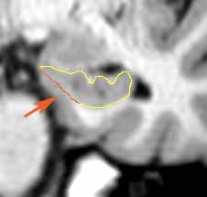

Fig. 7a: Red region indicates jump to clearly defined border

- Once the digitations become hazy, follow the ventricle outline to define the superior border of the hippocampus [See Fig. 8a].

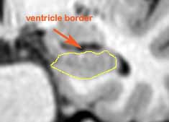

Fig. 8a

Hippocampal Body

9. When choroid plexus is encountered (inside of the lateral ventricle), follow the white border inferior to the plexus and meet the starting point, maintaining the general almond-like shape of the hippocampus in this region [See Fig. 9a].

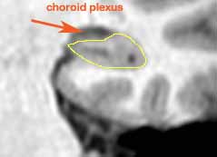

Fig. 9a

10. Exclude the hippocampal fissure when it is continuous with the lateral ventricle. Include the hippocampal fissure when it is not continuous with the lateral ventricle [See Fig. 9b].

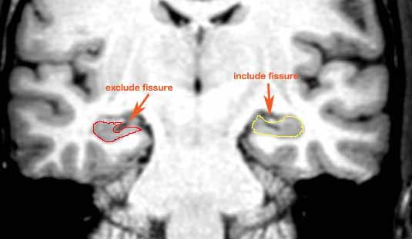

Fig. 9b

Hippocampal Tail

11. The general trend regarding the hippocampal tail is for the structure to become small, then larger when the superior and inferior horns of the lateral ventricle meet, and then narrow and small as it begins to disappear. When the superior and inferior horns of the lateral ventricle meet and the pulvinar nucleus of the thalamus has disappeared, the hippocampus changes shape and tends to tilt upwards [See Fig. 10a, 10b, and 10c].
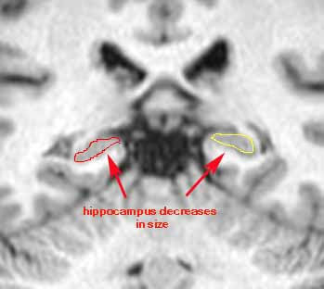

Fig. 10a: Superior and inferior horns of the lateral ventricle are separated

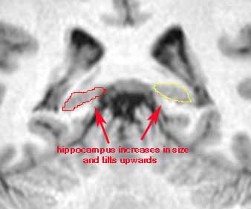

Fig. 10b: Superior and inferior horns of the lateral ventricle are continuous
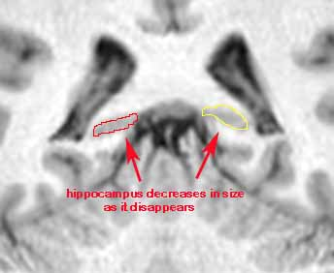
Fig. 10c: Superior and inferior horns of the lateral ventricle are continuous

12. Hippocampus disappears at ~slice # 95, 1 or 2 slides before it will turn into narrow structure, oval in shape. It is not unusual for the hippocampus to end on different slices for each hemisphere [See Fig. 11a].

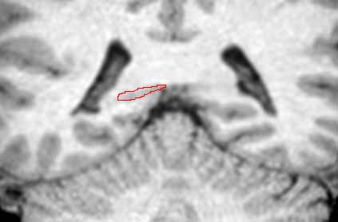

Fig. 11a

12. Occasionally, the size of the hippocampus can change dramatically within one or two slices [See Fig. 12a and 12b].

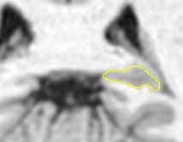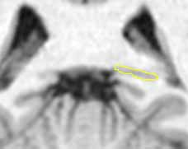
Fig. 12a: Anterior slice Fig. 12b: Posterior slice

14. In some cases, the hippocampus will take on an irregular shape and structure [See Fig. 13a and 13b].

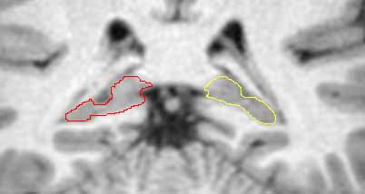

Fig. 13a: Hippocampus has an irregular shape

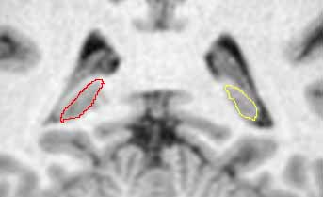

Fig. 13b: Hippocampus has an extreme vertical tilt

